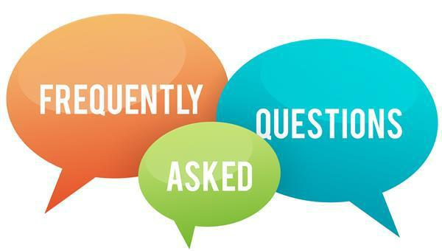

1. Can you check on my child throughout the year?
I make regular visits to every classroom every month. I stay in close contact with teachers who may have concerns about any of their students and can meet with students individually when they are struggling. If a parent or teacher has a specific concern that is affecting the student’s ability to learn in the classroom, a permission slip can be signed so that I can check in with the student periodically.
2. Can you stay in contact with parents throughout the year?
When I meet with students individually or in a small group, I try to keep the parents updated about how things are going. I am always available to parents through email, calling me on my office phone, or by making an appointment with me through the main office. My email address is amrobinson@dsdmail.net. My office phone number is (801) 402-2207.
3. How available are you to students? How do kids make an appointment to see you? Can kids just walk in anytime to see you?
I am at the school every day and am always available to students. When I am away from my office, there is a mailbox outside my door where students can leave a note letting me know they need to talk. I will pull the student from class to check in with them as soon as possible. If there is a student that is having a difficult time and I am in my office, I will be available to meet with them in that moment. Otherwise, the main office knows how to find me in the event of an emergency.
4. Do you provide a safe and confidential place for my student to share hard feelings and experiences? Is your office a place where kids can go when they feel they have nowhere else to go and know they will be heard? Can I be assured that my students’ privacy and safety is protected? Will your conversations be secure, safe, and confidential?
Absolutely! I strive to be a safe person at school that the students know they can depend on to talk to if they need to talk. I care a lot about my students and will always advocate for their well-being and what is in their best interest. The things that are discussed in my office stay in my office unless: someone is hurting the student, the student wants to hurt themself, the student wants to hurt someone else, or the student gives me permission to share information with another adult

5. My student is very shy and struggles in social situations. Can you help him/her feel more confident and independent?
The time I spend in the classroom with students is focused on different aspects of social emotional learning, so there will be lessons that will address social skills and other subjects that will help reinforce these things.
6. Will my student feel guilty or embarrassed when they go to your office?
I take visiting with students very seriously. I would never want any student to feel guilty or embarrassed when they come to my office. If they don’t want other kids to know they are coming to my office, I can make arrangements with the teacher to send the student “on an errand” so that other kids don’t know where they are going.
7. Do you teach SEL (Social Emotional Learning) and other healthy coping techniques?
Teachers have also been given SEL materials and resources to use in the classroom. My classroom guidance lessons will focus on social skills, coping skills, problem solving skills, etc.
8. Where is your office located?
My office is in the library.
9. Can people walk in and overhear the conversation you are having with my student?
Confidentiality is very important! When I am meeting alone with a student, the door is closed and no one is allowed in the room without the student’s permission (for example, in cases of a conflict between students). Teachers and other staff members never enter my office when the door is closed.
10. Can you take students one on one a couple of times a month and go over any frustrations my student might feel?
In general, it would be very difficult to meet with every student a couple of times a month. However, if there is a concern that is affecting the student’s ability to learn in the classroom, I can get a signed permission slip from the parent and can check in with them periodically.
11. Does the school counselor do individual counseling? Group counseling?
Yes! If a teacher or parent has a concern, they would like me to discuss with the student, a permission slip will need to be signed and I will put the student on my calendar. I can do short-term (6-8 sessions) of solution focused individual counseling. When there is a group of students in the same grade with the same struggles, I can organize a small group to address the problem.

